Techniques to Reduce Anxiety
It’s important to not only look after your physical health during the current Coronavirus (COVID-19) outbreak, but also your mental and emotional health. Here are some quick tips to staying well:
- Plan ahead to feel more in control.
- Learn to be in the moment.
- Prioritize good sleep.
- Exercise & eat well
5-4-3-2-1 Technique: Using the 5-4-3-2-1 technique, you will purposefully take in the details of your surroundings using each of your senses. Strive to notice small details that your mind would usually tune out, such as distant sounds, or the texture of an ordinary object.
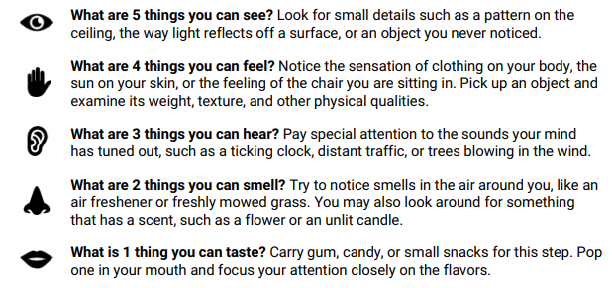
Body Awareness: The body awareness technique will bring you into the here-and-now by directing your focus to sensations in the body. Pay special attention to the physical sensations (complete as many steps as you feel comfortable):
- Take 5 long, deep breaths through your nose, and exhale through puckered lips.
- Place both feet flat on the floor. Wiggle your toes. Curl and uncurl your toes several times. Spend a moment noticing the sensations in your feet.
- Clench your hands into fists, and then release the tension. Repeat this 10 times.
- Press your palms together. Press them harder and hold this pose for 15 seconds. Pay attention to the feeling of tension in your hands and arms.
- Reach your hands over your head like you’re trying to reach the sky. Stretch like this for 5 seconds. Brings your arms down and let them relax at your sides.
- Take 5 more deep breaths and notice the feeling of calm in your body.

