FORT BEND COUNTY BAIL BOND BOARD
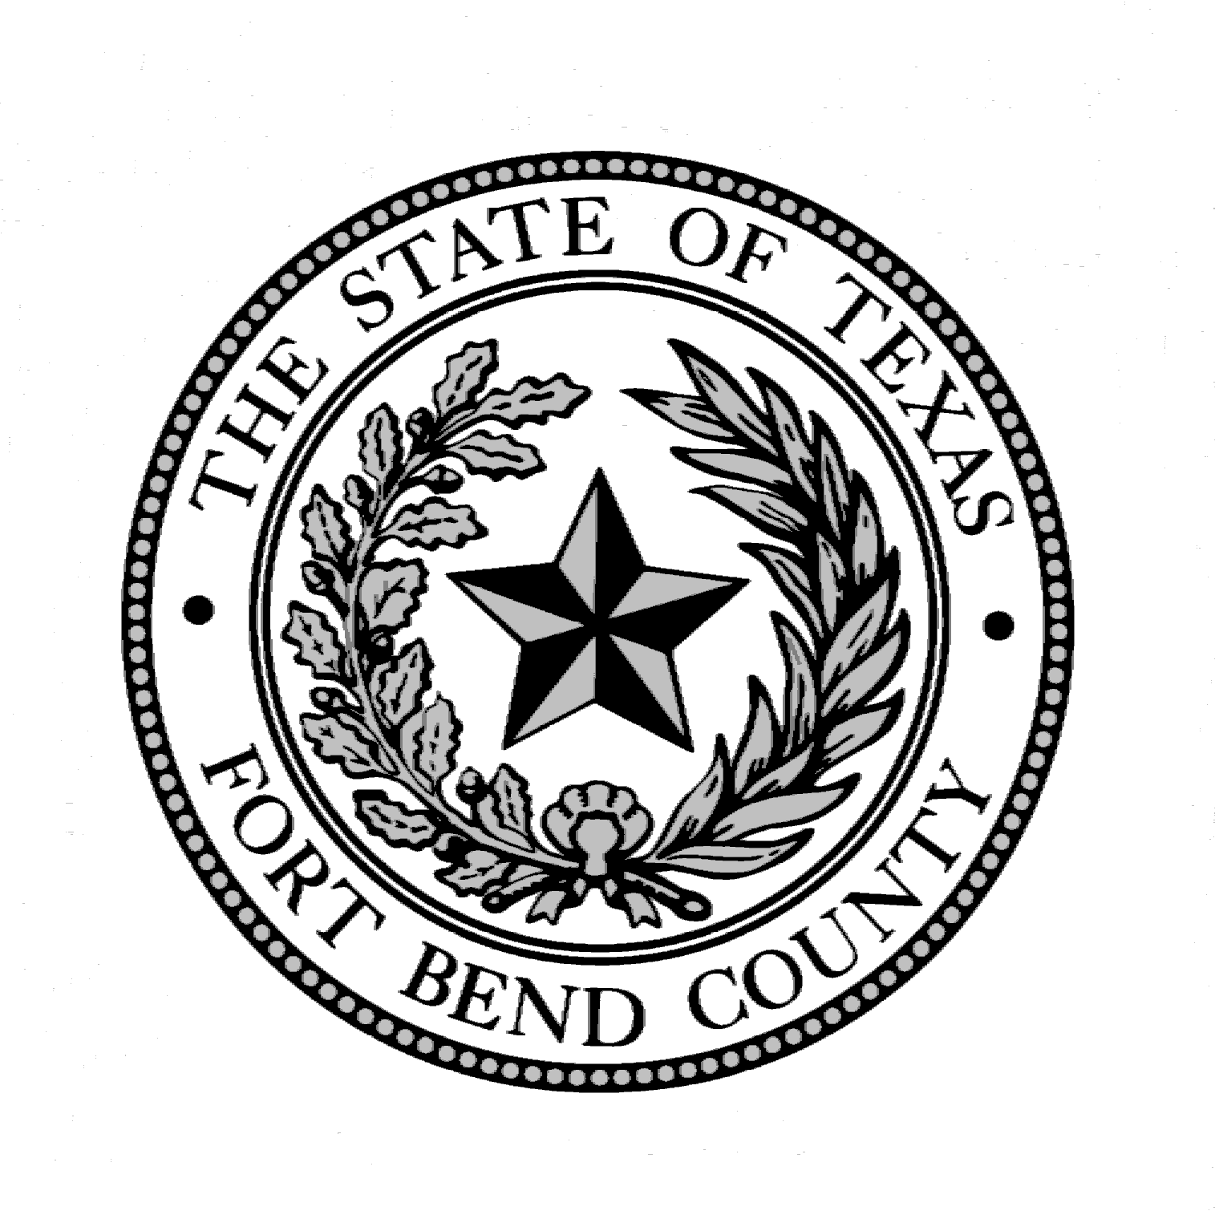

BAIL BONDSMEN REPRESENTATIVE

BALLOT

PLEASE SELECT YOUR BAIL BOND LICENSEE NOMINEE TO SERVE ON THE FORT BEND COUNTY BAIL BOND BOARD FOR THE 2022 CALENDAR YEAR. RETURN TO THE BAIL BOND BOARD ADMINISTRATOR'S OFFICE LOCATED AT 1422 EUGENE HEIMANN CIRCLE, SUITE 20242, RICHMOND, TEXAS 77469 NO LATER THAN NOVEMBER 30, 2022 IN A PLAIN, UNMARKED ENVELOPE WHICH SHALL BE PLACED IN AN EXTERIOR ENVELOPE SIGNED BY THE PERSON SUBMITTING THE BALLOT.

_______________________________________________________
(Please print Bondsmen Name)

_____________________________________________________________
(Please print Bonding Company name)

Each individual licensed in the county as a Bail Bond Surety or as an Agent for a Corporate Surety
is entitled to cast one vote.

