**APPENDIX A**

OWNER'S ACKNOWLEDGMENT

EXAMPLE FORM

STATE OF TEXAS

COUNTY OF FORT BEND

I (or we), {name(s) of owner(s) if individual(s)} or (name of president and secretary or authorized trust officer of a company or corporation) being officers of (name of company or corporation), owner (or owners) of the (number of acres) tract described in the above and foregoing map of (name of subdivision or development), do hereby make and establish said subdivision and development plat of said property according to all lines, dedications, restrictions and notations on said maps or plat and hereby dedicate to the use of the public forever, all streets (except those streets designated as private streets), alleys, parks, water courses, drains, easements and public places shown thereon for the purposes and considerations therein expressed; and do hereby bind myself (or ourselves), my (or our) heirs and assigns to warrant and forever defend the title to the land so dedicated.

FURTHER, I (or we) do hereby dedicate for public utility purposes an unobstructed aerial easement five (5) feet in width from a plane twenty (20) feet above the ground level upward, located adjacent to all public utility easements shown hereon.

FURTHER, I (or we) do hereby declare that all parcels of land designated as lots on this plat are intended for the construction of single family residential dwelling units thereon (or the placement of mobile homes) and shall be restricted for same under the terms and conditions of such restrictions filed separately.

FURTHER, I (or we) do hereby covenant and agree that all of the property within the boundaries of this plat shall be restricted to prevent the drainage of any septic tanks into any public or private street, road or alley or any drainage ditch, either directly or indirectly.

ADDITIONAL PARAGRAPHS TO BE ADDED AS NEEDED:

(When streets within the plat are to be developed with open ditches).

FURTHER, I (or we) do hereby covenant and agree that all of the property within the boundaries of this plat shall be restricted to provide that drainage structures under driveways shall have a net drainage opening area of sufficient size to permit the free flow of water without backwater and in no instance have a drainage opening of less than one and three quarters (1 3/4) square feet (24" diameter).

(When subdivision contains natural drainage ways such as bayous, creeks, gullies, ravines, draws or drainage ditches).

FURTHER, I (or we) do hereby dedicate to the public a strip of land twenty (20) feet wide on each side of the center line of any and all bayous, creeks, gullies, ravines, draws and drainage ditches located in said subdivision, as easements for drainage purposes. Fort Bend County or any other governmental agency shall have the right to enter upon said easement at any and all times for the purposes of construction and maintenance of drainage facilities and structures.

FURTHER, I (or we) do hereby covenant and agree that all of the property within the boundaries of this subdivision and adjacent to any drainage easement, ditch, gully, creek or natural drainage way shall hereby be restricted to keep such drainage ways and easements clear of fences, buildings, excessive vegetation and other obstructions to the operations and maintenance of the drainage facility and that such abutting property shall not be permitted to drain directly into this easement except by means of an approved drainage structure.

(When the plat indicates building setback lines and public utility easements are to be established in adjacent acreage owned by the subdivider).

FURTHER, I (or we) do hereby certify that I am (or we are) the owner(s) of all property immediately adjacent to the boundaries of the above and foregoing subdivision of (Name of subdivision) where building setback lines or public utility easements are to be established outside the boundaries of the above and foregoing subdivision and do hereby make and establish all building setback lines and dedicate to the use of the public, all public utility easements shown in said adjacent acreage.

FURTHER, I (or we) do hereby acknowledge the receipt of the “Orders for Regulation of Outdoor Lighting in the Unincorporated Areas of Fort Bend County, Texas”, and do hereby covenant and agree and shall comply with this order as adopted by Fort Bend County Commissioners Court on March 23, 2004, and any subsequent amendments.

**APPENDIX B**

EXECUTION OF OWNER'S ACKNOWLEDGMENT

EXAMPLE FORM

(When owner is an individual or individuals)

WITNESS my (or our) hand in the City of , Texas, this (number) day of (month) , (year) .

______________________________________

(signature of owner or owners)

(names to be printed)

(When owner is a company or corporation)

IN TESTIMONY WHEREOF, the (name of company) has caused these presents to be signed by (name of president or vice-president), its (president or vice-president), hereunto authorized, attested by its Secretary (or authorized trust officer), (name of secretary or authorized trust officer), and its common seal hereunto affixed this (number) day of (month), (year).

___________________________________________

(Name of company)

By: (signature) .

president or vice-president)

(signature of secretary or

Attest: authorized trust officer)

Title

(affix corporate seal)

Note: All owners' signatures shall be acknowledged by a Notary Public.

**APPENDIX C**

LIENHOLDER'S ACKNOWLEDGMENT AND SUBORDINATION STATEMENT

Note: Holders of all liens against the property being platted must be a part of the final plat or prepare separate instruments which shall be filed for record with the plat.

EXAMPLE FORM

I, (or we), (name of mortgagee or names of mortgagees), owner and holder (or owners and holders) of a lien (or liens) against the property described in the plat known as (name of plat), against the property described instrument of record in Volume , Page , of the Official Records (or Deed of Trust Records) of Fort Bend County, Texas, do hereby in all things subordinate to said plat said lien(s) and I (or we) hereby in all things subordinate to said plat said lien(s) and I (or we) hereby confirm that I am (or we are) the present owner (or owners) of said lien(s) and have not assigned the same nor any part thereof.

______________________________________

By: (Signature of Lienholder)

(name to be printed)

Note: All lienholder signatures shall be acknowledged by a Notary Public.

**APPENDIX D**

NOTARY PUBLIC ACKNOWLEDGMENT FOR ALL SIGNATURES

STATE OF TEXAS

COUNTY OF

BEFORE ME, the undersigned authority, on this day personally appeared (names of persons signing the plat, owners, corporation officers and lienholder), (corporation titles if appropriate), known to me to be the persons whose names are subscribed to the foregoing instrument and acknowledge to me that they executed the same for the purposes and considerations therein expressed (add for corporations "and in the capacity therein and herein set out, and as the act and deed of said corporation.")

GIVEN UNDER MY HAND AND SEAL OF OFFICE, THIS (number) day of (month), (year).

_______________________________________

(signature of notary public)

Notary Public in and for

(name of County) County, Texas

(affix Notary Seal)

**APPENDIX E**

CERTIFICATE FOR SURVEYOR

I, , am authorized under the laws of the State of Texas to practice the profession of surveying and hereby certify that the above subdivision is true and correct, was prepared from an actual survey of the property made under my supervision on the ground and that all boundary corners, angles points of curvature and other points of reference have been marked with iron (or other suitable permanent ferrous metal) pipes and a length of not less than three (3) feet.

_____________________________________

(signature of surveyor)

(Print name)

Texas Registration No.___________________

(Affix Seal)

**APPENDIX F**

CERTIFICATE OF FORT BEND COUNTY ENGINEER

AND COMMISSIONERS’ COURT

I, , FORT BEND COUNTY ENGINEER, DO HEREBY CERTIFY THAT THE PLAT OF THIS SUBDIVISION COMPLIES WITH ALL OF THE EXISTING RULES AND REGULATIONS OF THIS OFFICE AS ADOPTED BY THE FORT BEND COUNTY COMMISSIONERS' COURT. HOWEVER, NO CERTIFICATION IS HEREBY GIVEN AS TO THE EFFECT OF DRAINAGE FROM THIS SUBDIVISION ON THE INTERCEPTING DRAINAGE ARTERY OR PARENT STREAM OR ON ANY OTHER AREA OR SUBDIVISION WITHIN THE WATERSHED.

_________________________________________

FORT BEND COUNTY ENGINEER

APPROVED BY THE COMMISSIONERS' COURT OF FORT BEND COUNTY, TEXAS, THIS DAY OF , .

_________________________________________

PRECINCT 1, COUNTY COMMISSIONER

_________________________________________

PRECINCT 2, COUNTY COMMISSIONER

_________________________________________

PRECINCT 3, COUNTY COMMISSIONER

_________________________________________

PRECINCT 4, COUNTY COMMISSIONER

_________________________________________

COUNTY JUDGE

**APPENDIX G**

COUNTY CLERK'S FILING ACKNOWLEDGMENT STATEMENT

I, , COUNTY CLERK IN AND FOR FORT BEND COUNTY, HEREBY CERTIFY THAT THE FOREGOING INSTRUMENT WITH ITS CERTIFICATE OF AUTHENTICATION WAS FILED FOR RECORDATION IN MY OFFICE ON _______ __________ , AT O'CLOCK m. IN PLAT NUMBER OF THE PLAT RECORDS OF FORT BEND COUNTY, TEXAS.

WITNESS MY HAND AND SEAL OF OFFICE, AT RICHMOND, TEXAS. THE DAY AND DATE LAST ABOVE WRITTEN.

______________________________________

COUNTY CLERK FORT BEND COUNTY, TEXAS

BY: __________________________________

DEPUTY

**APPENDIX H**

ENGINEER'S PLAT AFFIDAVIT

I, , A PROFESSIONAL ENGINEER REGISTERED IN THE STATE OF TEXAS DO HEREBY CERTIFY THAT THIS PLAT MEETS ALL REQUIREMENTS OF FORT BEND COUNTY TO THE BEST OF MY KNOWLEDGE.

__________________________________

(signature and title)

(seal)

**APPENDIX I**

ENGINEER'S CONSTRUCTION COMPLIANCE STATEMENT

Plat Name:

I, , a professional engineer licensed/registered in the State of Texas do hereby certify that:

*(plat/project name)*

was under periodic inspection during construction and to the best of my knowledge was constructed in accordance with the recorded plat and approved construction documents. Items identified in the construction material testing reports and summary will be discussed during the inspection and added to the punch list as needed. This is a statement of my professional opinion, and shall not be construed as a guarantee or warranty of any kind.

(Signature)

SEAL

(Date)

(Title)

(Company)

(Firm #)

**APPENDIX J**

CONTRACTOR/CONTRACTORS AFFIDAVIT OF CONSTRUCTION COMPLIANCE

Plat Name:

I, do hereby certify that the construction of this project complies with the approved construction documents. Items identified in the construction material testing reports and summary will be discussed during the inspection and added to the punch list as needed.

(Signature)

SEAL (Date)

(Title)

(Company)

(A separate affidavit will be required for each Contractor, unless all work was assigned to a General Contractor who accepts responsibility for all work. Each affidavit may be qualified by a description of work performed by the applicable contractor.)

**APPENDIX K**

INDEPENDENT TESTING LABORATORY CERTIFICATION

Plat/Project Name:

Based on the services provided by _____________________________________________________ ,

I, __________________________________ , a professional engineer licensed/registered in the State of Texas, confirm that the samples of the materials tested and/or the elements of the work observed, to the best of my knowledge, met the requirements specified in the approved construction documents applicable to: *(plat/project name)* . Items identified in the construction material testing reports and summary will be discussed during the inspection and added to the punch list as needed. This is a statement of my professional opinion, and shall not be construed as a guarantee or warranty of any kind.

(Signature)

SEAL

(Date)

(Title)

(Company)

(Firm #)

**APPENDIX L**

STREET AND ROAD INVENTORY

|  |  |  |  |  |  |  |  |  |  |  |  |
| --- | --- | --- | --- | --- | --- | --- | --- | --- | --- | --- | --- |
| NAME OF SUBDIVISION Date Approved: | | | | | | | | | | | |
| No. | Voter  Box | Road  Surface | Row  Width | Pvmt.  Width | N/S  Zone | Street  Name | From | To | Feet | Miles | Key  Map |
| 1 |  |  |  |  |  |  |  |  |  |  |  |
| 2 |  |  |  |  |  |  |  |  |  |  |  |
| 3 |  |  |  |  |  |  |  |  |  |  |  |
| 4 |  |  |  |  |  |  |  |  |  |  |  |
| 5 |  |  |  |  |  |  |  |  |  |  |  |
| 6 |  |  |  |  |  |  |  |  |  |  |  |
| 7 |  |  |  |  |  |  |  |  |  |  |  |
| 8 |  |  |  |  |  |  |  |  |  |  |  |
| 9 |  |  |  |  |  |  |  |  |  |  |  |
| 10 |  |  |  |  |  |  |  |  |  |  |  |
| 11 |  |  |  |  |  |  |  |  |  |  |  |
| 12 |  |  |  |  |  |  |  |  |  |  |  |
| 13 |  |  |  |  |  |  |  |  |  |  |  |
| 14 |  |  |  |  |  |  |  |  |  |  |  |
| 15 |  |  |  |  |  |  |  |  |  |  |  |
| 16 |  |  |  |  |  |  |  |  |  |  |  |
| 17 |  |  |  |  |  |  |  |  |  |  |  |
| 18 |  |  |  |  |  |  |  |  |  |  |  |
| 19 |  |  |  |  |  |  |  |  |  |  |  |
| 20 |  |  |  |  |  |  |  |  |  |  |  |

**APPENDIX M**

**BOND**

NO.

THE STATE OF TEXAS §

§ KNOW ALL MEN BY THESE PRESENTS:

COUNTY OF FORT BEND §

THAT WE,  whose *(street address/phone)* is , hereinafter called the Principal, and *(Surety)* , a Corporation existing under and by virtue of the laws of the State of  , and authorized to do an indemnifying business in the State of Texas, and whose principal office is located at *(street address/phone)* ,whose officer residing in the State of Texas, authorized to accept service in all suits and actions brought within said State is *(name/office)* , and whose *(street address/phone)* is , hereinafter called the Surety, and held and firmly bound unto *{name of current County Judge}*, County Judge of Fort Bend County, Texas or his successors in office, in the full sum of  Dollars ($     ) current, lawful money of the United States of America, to be paid to said *{name of current County Judge}*, County Judge of Fort Bend County, Texas or his successors in office, to which payment well and truly to be made and done, we, the undersigned, bind ourselves and each of us, our heirs, executors, administrators, successors, assigns, and legal representatives, jointly and severally, by these presents.

WHEREAS, the said Principal is the owner of the following Subdivision(s):

located in Fort Bend County, Texas; and,

WHEREAS, the Commissioners Court of Fort Bend County, Texas, has promulgated certain rules, regulations and requirements relating to Subdivisions in Fort Bend County, Texas, as more specifically set out in “Fort Bend County Regulations of Subdivisions” as amended; same being made a part hereof for all purposes, as though fully set out herein; wherein it is provided, among other things, that the owner of a Subdivision will construct the roads, streets, bridges and drainage in the right-of-way depicted on the plat thereof, in accordance with the specifications set out therein, and maintain such roads, streets, bridges and drainage in the right-of-way until such time as said roads, streets, bridges and drainage in the right-of-way have been approved by the County Engineer and accepted for maintenance by the Commissioners Court of Fort Bend County, Texas (or in the case of subdivisions, streets or roads designated as private in the plat approved by the County Engineer and accepted by the Homeowners Association).

It is further stipulated and understood that the approval of the map or plat of the above named Subdivision(s) is conditioned upon and subject to the strict compliance by the Principal herein with the aforesaid specifications, and that the terms of said specifications, including all deletions, additions, changes or modifications of any kind or character, constitute a contract between the County of Fort Bend and Principal; and it is understood by the Principal that the approval of said map or plat of the above Subdivision(s) was obtained only by the undertaking of the Principal to so comply with the said regulations and specifications within a reasonable time, as set by the Commissioners Court of Fort Bend County, Texas, and that without such undertaking such approval would have not been granted.

NOW THE CONDITION OF THIS OBLIGATION IS SUCH, that if the above bounded Principal, his, her, their, or its heirs, executors, administrators, successors, assigns, and legal representatives, and each and every one of them to do in all things well and truly observe, perform, fulfill, keep and comply with all and singular the rules, regulations, requirements and specifications above referred to, including any deletions, additions, changes or modifications of any kind or character, in the construction and maintenance of all roads, streets, bridges and drainage in the right-of-way in the above named Subdivision(s) and that upon approval of the construction of said roads, streets, bridges and drainage in the right-of-way by the County Engineer, and upon the approval of such maintenance by the County Engineer, and upon acceptance of such roads, streets, bridges and drainage in the right-of-way by the Commissioners Court of Fort Bend County, Texas, then this obligation to be void and of no force and effect.

The Principal and Surety hereon each agree, bind and obligate themselves to pay *{name of current County Judge}*, County Judge of Fort Bend County, State of Texas, or his successors in office, for the use and benefit of Fort Bend County, all loss or damages to it occasioned by reason of the failure of the Principal to comply strictly with each and every provision contained in the rules, regulations, requirements and specifications above referred to relating to the construction and maintenance of roads, streets, bridges and drainage in the right-of-way in the above named Subdivision(s), and further agree, bind and obligate themselves to defend, save and keep harmless the County of Fort Bend from any and all damages, expenses, and claims of every kind and character which the County of Fort Bend may suffer, directly or indirectly, as a result of the Principal’s failure to comply with the rules, regulations and specifications relating to the construction and maintenance of the roads, streets, bridges and drainage in the right-of-way in the above named Subdivision(s).

The word Principal when used herein means Principal or Principals whether an individual, individuals, partnership, corporation, or other legal entity having the capacity to contract. The words Roads, Streets, Bridges and Drainage in the right-of-way used herein mean each and every road, street, bridge and drainage in the right-of-way in said Subdivision(s). The word Maintenance as used herein means all needful, necessary and proper care and repair from completion of the roads or streets and approval thereof by the County Engineer until acceptance of the roads and streets by the Commissioners Court. The word Surety when used herein means Surety or Sureties, and it is understood by the parties that any and all liabilities of any kind or character assumed or imposed upon the Principal by the terms hereof extends in full force and vigor to each and every Surety jointly and severally.

In the event of suit hereunder, such suit shall be brought in Fort Bend County, Texas.

EXECUTED this       day of       , 20       .

ATTEST:

Secretary Principal By:

Surety

By:

ATTORNEY IN FACT

APPROVED this __day of , 20 _ in Fort Bend County Commissioners Court.

ATTEST:

*{name of current County Clerk}* *{name of current County Judge}*

County Clerk County Judge

Fort Bend County, Texas

**APPENDIX N**

Fort Bend County Judge {*name of current County Judge*}

or his successors in office

Richmond, Texas 77469

Irrevocable

Letter of Credit

No. ________________________

Date _______________________

Gentlemen:

We hereby establish our Irrevocable Letter of Credit in your favor for the account of (Developer or Principal) , *(Address)* , Texas, for a sum or sums, not to exceed in the aggregate, the amount of ______________________________________ Dollars ($ ), in U. S. Dollars, available by your draft at sight drawn on us, to be accompanied by an affidavit from Fort Bend County Judge {*insert name of current County Judge*}, or his successors in office, stating one of the following:

1. "The undersigned, Fort Bend County Judge {*insert name of current County Judge*}, or his successors in office, hereby certifies to *(Bank)* as the issuer of Letter of Credit No. dated , in the amount of ___________________________________ ($ ), that *(Principal or Developer)*  has failed to build and/or maintain roads, streets and bridges within *(Name of Subdivision)* , in accordance with the Subdivision Regulations of Fort Bend County, Texas, prior to the roads, streets and bridges being accepted for permanent maintenance by Fort Bend County (or in the case of subdivisions, streets or roads designated as private in the plat approved by the County Engineer and accepted by the Homeowners Association) and, by virtue of such failure, Beneficiary is entitled to receive funds in the amount of *(to be left blank)* Dollars ($ *(to be left blank)* )".

2. "The undersigned, Fort Bend County Judge {*name of current County Judge*}, or his successors in office, hereby certifies to *(Bank)* as the issuer of Letter of Credit No. dated, in the amount of _________________________________ ($ ), that *(Principal or Developer)* has delivered notice of intent to not automatically renew Letter of Credit No. for a period no less than one year from the present expiration date and, by virtue of said delivery and notification, beneficiary is entitled to receive funds equal in amount to the undrawn balance of this Letter of Credit, such amount being *(to be left blank)* Dollars ($ *(to be left blank)* )".

It is the condition of this Letter of Credit that it shall be automatically renewed for a period no less than one year from the present or each future expiration date, unless at least 30 days prior to such date we, the Issuer, shall notify Fort Bend County Judge {*name of current County Judge*}, or his successor in office, that we elect not to renew this letter of Credit for such additional periods.

Partial drawings on this letter of Credit are permitted.

Notwithstanding any reference in this Letter of Credit to other documents, instruments or agreements, or references in such other documents, instruments or agreements to this Letter of Credit, this Letter of Credit contains the entire agreement among the account party, beneficiary and the issuer hereunder relating to the obligations of the issuer hereunder.

Any draft drawn under this Letter of Credit must be marked "Drawn under Letter of Credit No. dated , 20 issued by *(Bank)* . All drafts drawn under and in compliance with the terms of this Letter of Credit will be duly honored by us on due presentation at our counters on or before , 20 , or on or before the expiration date of any subsequent renewal period.

_______________________________________

Issuing Organization

By: ____________________________________

Name: __________________________________

Title: ___________________________________

**APPENDIX O**

ENGINEER'S DRAINAGE FACILITIES CONSTRUCTION CERTIFICATION

Plat Name: _________________________________________________________________

I,___________________________________ , a professional engineer licensed/registered in the State of Texas, do certify to the best of my knowledge that all drainage facilities meet the requirements of the Fort Bend County Drainage Criteria Manual and have been constructed in accordance with the recorded plat and approved construction documents. Items identified in the construction material testing reports and summary will be discussed during the inspection and added to the punch list as needed.

(Signature)

SEAL

(Date)

(Title)

(Company)

(Firm #)

**APPENDIX P**

FORT BEND COUNTY

SUPPLEMENTAL REGULATIONS OF SUBDIVISIONS

FOR THE EXTRATERRITORIAL JURISDICTION

OF SUGAR LAND, TEXAS

I.

PROVISIONS RETAINED

1.01 This Policy is a supplement to the Fort Bend County Subdivision Platting Policy (revised October 1992). It is not the intention that this supplemental policy supersede and it shall not be deemed to supersede that comprehensive policy.

1.02 This Policy shall apply only to the subdivision of land and development of property which is both in Fort Bend County and the Extraterritorial Jurisdiction of the City of Sugar Land, Texas.

II.

PLAT SUBMITTAL

2.01 The technical requirements of the Fort Bend Subdivision Platting Policy, Section 3, shall apply to subdivision in the ETJ.

2.02 Subdivision plats for development in the ETJ shall be presented to the Planning and Zoning Commission of Sugar Land, Texas.

2.03 Upon approval of and execution of a plat by the Sugar Land City Council, it shall be delivered to the office of the Fort Bend County Engineer.

2.04 Upon completion of the County's technical review, the plat shall be presented to the Commissioners' Court for approval.

2.05 If the plat is approved by the Commissioners' Court, it shall be fully-executed and returned immediately to the County Engineer to be held in trust by the County Engineer for the County and the City.

2.06 A developer or subdivider whose plat has been approved and executed by the City and the County, and deposited in trust with the County Engineer, may commence construction of drainage, sanitary and water services ("Utilities") for the platted subdivision.

III.

PAVING AND BONDING

3.01 A developer or subdivider whose Utilities, commenced pursuant to Section II, above, are at or near completion shall then comply with any surety/bonding requirements for paving, sidewalks, etc. of both the City and the County.

3.02 Upon written concurrence between the City and the County that all of the required bonds or other assurance have been received and approved by both jurisdictions, the County Engineer will release the plat from trust and deposit it for recording with the County Clerk. The developer or subdivider shall be responsible for coordinating the payment of the filing fee with the County Engineer. The release of the plat from trust shall be accomplished only upon order of the Commissioners' Court.

IV.

REVIEW OF COMPLETED CONSTRUCTION

4.01 Neither the City nor the County shall release a bond or other assurance securing the developer's or subdivider's performance under this supplemental policy without reviewing each other's written comments regarding the adequacy and completeness of the construction secured by the bond(s) in question.

4.02 Notwithstanding the review requirement of §4.01, above, both the City and the County shall have full and independent authority to release or retain any bond or other surety instrument wherein they are the sole assured party or beneficiary.

V.

EFFECTIVE DATE

5.01 This supplemental policy shall be effective upon the date of formal acceptance by both the City of Sugar Land, Texas and Fort Bend County, Texas.

5.02 This policy may be abrogated by either jurisdiction by giving written notice at any time after adoption. However, any plat, which is at the time of termination being held in trust by the County Engineer, shall continue to be subject to the terms of this supplemental policy.

IV.

STALE PLATS

6.01 Any plat held in trust by the County Engineer pursuant to this supplemental policy for longer than a year ("stale plat"), shall be subject to review by the County and the City.

6.02 Any plat subject to review pursuant to this section may be reconsidered by either or both jurisdictions. Upon the motion of either jurisdiction, or upon the concurrence of both jurisdictions, a state plat may be subject to the following:

1. Be granted an additional period of time to the held in trust, during which period utilities must be completed;

2. Rescission of approval by either or both jurisdictions.

6.03 The County Engineer shall maintain a call-up system to monitor plats held in trust.

**APPENDIX Q**

ENGINEER'S CONSTRUCTION DOCUMENT CERTIFICATION STATEMENT

I, (printed name) A PROFESSIONAL ENGINEER REGISTERED IN THE STATE OF TEXAS DO HEREBY CERTIFY THAT THESE CONSTRUCTION DOCUMENTS WERE PREPARED UNDER MY DIRECT SUPERVISION AND DO MEET OR EXCEED THE SPECIFICATIONS AND REQUIREMENTS OF FORT BEND COUNTY, TEXAS.

________________________________________

(signature and date)

________________________________________

SEAL (title)

**APPENDIX R**

TYPICAL ROADWAY SECTION

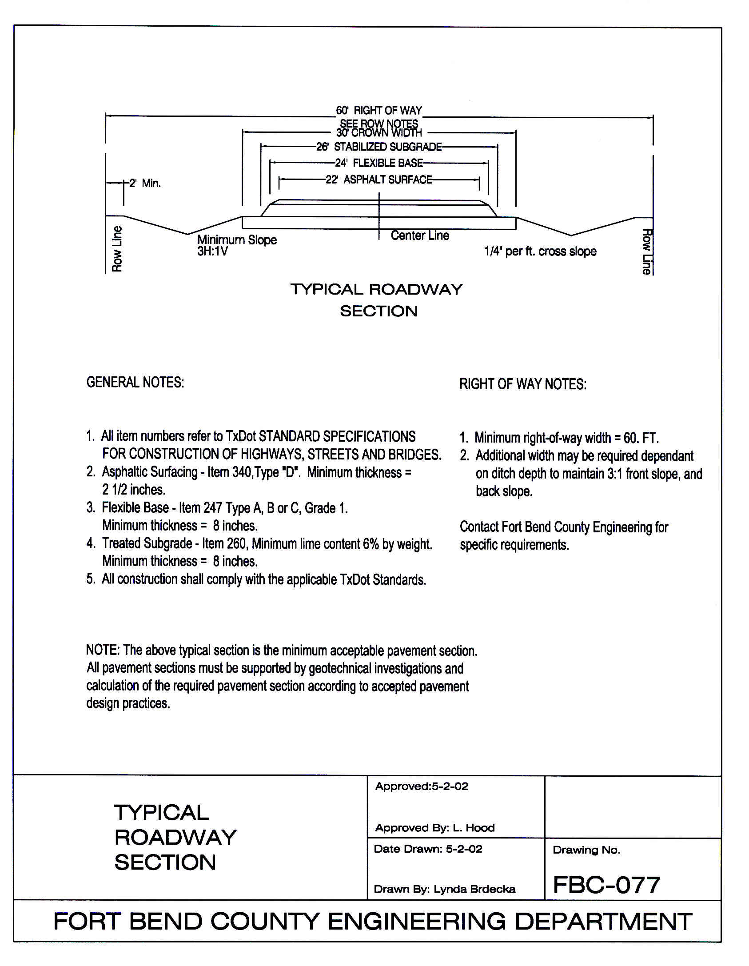**APPENDIX S**

TAXING ENTITY LETTER

(When filing a plat with the Fort Bend County Clerks office it will be necessary to submit a letter listing all the taxing entities involved in the platted land. The letter must be from the plat filer (or the responsible party). The letter needs to be submitted to the Engineering Office along with the original tax certificates. It does need to be addressed to the County Clerk’s Office. All items will be placed in the folder that goes to Commissioners’ Court when the plat is filed.

EXAMPLE LETTER

Date

Ms. Laura Richard

Fort Bend County Clerk

Fort Bend County Clerks Office

301 Jackson

Richmond, Texas 77469

**RE: Taxing Entities for** *(Name of Subdivision)* .

Dear Ms. Richard:

Below is a listing of the Taxing Entities for  *( Name of Subdivision)*  .

1. Fort Bend County Municipal Utilities District No. 117

2. Fort Bend County Levee Improvement District No. 11

3. Lamar Consolidated Independent School District

4. Fort Bend County

Please let me know if you have any questions.

Sincerely,

*Name of plat filer or responsible party*

*Title*

APPENDIX T

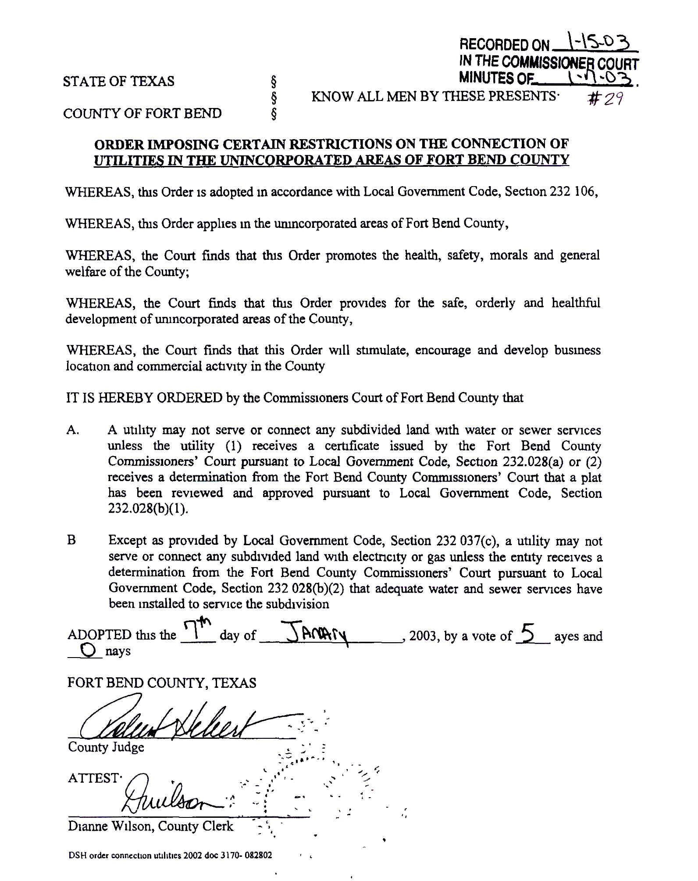

APPENDIX U

FORT BEND COUNTY

SUBDIVISION PLAT APPLICATION



APPENDIX V

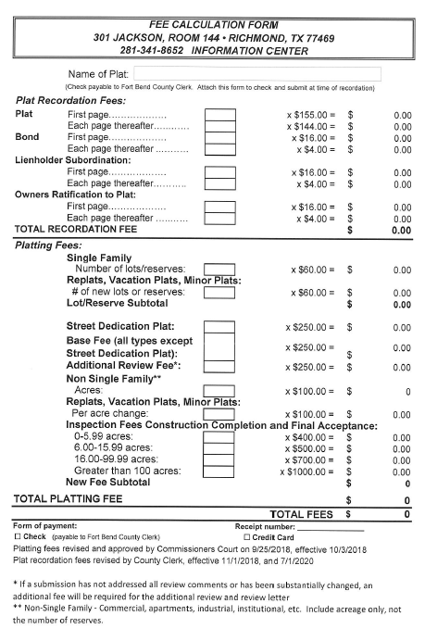

APPENDIX W

LIST OF SPECIFIC TYPES OF TREES THAT WILL BE CONSIDERED ACCEPTABLE FOR GREENSPACE LANDSCAPE RESERVES:

|  |  |  |  |
| --- | --- | --- | --- |
| **Botanical**  **Name** | **Common**  **Name** | **Size** | **Remarks, Minimum Heights,**  **Caliper and Spread** |

|  |  |  |  |
| --- | --- | --- | --- |
| CANOPY TREES | | | |
| Caryaillinosis | Pecan | 30 gal | 2-2½” cal., 8-10’ Ht., 4-5’ spr., 4-5’ branch ht. |
| Magnolia grandiflora | Southern Magnolia | 30 gal | 2-2½” cal., 8-10’ Ht., 4-5’ spr., 4-5’ branch ht. |
| Pistache chinensis | Chinese Pistache | 30 gal | 2-2½” cal., 8-10’ Ht., 4-5’ spr., 4-5’ branch ht. |
| Quercus macrocarpa | Burr Oak | 30 gal | 2-2½” cal., 8-10’ Ht., 4-5’ spr., 4-5’ branch ht. |
| Quercus nigra | Water Oak | 30 gal | 2-2½” cal., 8-10’ Ht., 4-5’ spr., 4-5’ branch ht. |
| Quercus shumardii | Shurmard Oak | 30 gal | 2-2½” cal., 8-10’ Ht., 4-5’ spr., 4-5’ branch ht. |
| Quercus texana | Red Oak | 30 gal | 2-2½” cal., 8-10’ Ht., 4-5’ spr., 4-5’ branch ht. |
| Quercus virginiana | Live Oak | 30 gal | 2-2½” cal., 8-10’ Ht., 4-5’ spr., 4-5’ branch ht. |
| Ulmus parvifolia Drake | Drake Elm | 30 gal | 2-2½” cal., 8-10’ Ht., 4-5’ spr., 4-5’ branch ht. |

|  |  |  |  |
| --- | --- | --- | --- |
| EVERGREEN TREES | | | |
| Ilex opaca | American Holly | 45 gal | 8-10” Ht., 5-6’ spr., full branching |
| Ilex opaca Savannah | Savannah Holly | 45 gal | 8-10” Ht., 5-6’ spr., full branching |

|  |  |  |  |
| --- | --- | --- | --- |
| ORNAMENTAL TREES | | | |
| Chionanthus virginica | Chinese Fringe Tree | 30 gal | 10-12’ Ht., 5-6’ spr. 2-2½” cal. full branching |
| Crateagus marshalli | Parsley Hawthorn | 30 gal | 10-12’ Ht., 5-6’ spr. 2-2½” cal., 4-6 canes,  full branching |
| Diospyros kaki | Japanese Persimmon | 30 gal | 10-12’ Ht., 5-6’ spr. 2-2½” cal., 4-6 canes,  full branching |
| Koelruteria bipinnata | Golden Rain Tree | 30 gal | 10-12’ Ht., 5-6’ spr. 2-2½” cal., 4-6 canes,  full branching |
| Lagerstroemia indica | Crape Myrtle | 30 gal | 10-12’ Ht., 5-6’ spr. 2-2½” cal., 4-6 canes,  full branching |
| Magnolia liliiflora | Lily Magnolia | 30 gal | 10-12’ Ht., 5-6’ spr. 2-2½” cal., 4-6 canes,  full branching |
| Magnolia soulangeana | Saucer Magnolia |  | 10-12’ Ht., 5-6’ spr. 2-2½” cal., 4-6 canes,  full branching |
| Magnolia stellata | Star Magnolia | 30 gal | 10-12’ Ht., 5-6’ spr. 2-2½” cal., 4-6 canes,  full branching |
| Magnolia virginiana | Sweet Bay Magnolia | 30 gal | 10-12’ Ht., 5-6’ spr. 2-2½” cal., 4-6 canes,  full branching |
| Prunus mexicano | Mexican Plum | 30 gal | 10-12’ Ht., 5-6’ spr. 2-2½” cal., full branching |
| Pyrus calleryana ‘Aristocrat’ or ‘Capitol’ | Flowering Pears | 30 gal | 10-12’ Ht., 5-6’ spr. 2-2½” cal., full branching |

|  |  |  |  |
| --- | --- | --- | --- |
| **Botanical**  **Name** | **Common**  **Name** | **Size** | **Remarks, Minimum Heights,**  **Caliper and Spread** |

|  |  |  |  |
| --- | --- | --- | --- |
| SHRUBS | | | |
| Abelia spp. | Abelia | 3-5 gal | 24-30” Ht., 18-24” spr., matching, full branching, 36” o.c. |
| Anisacanthus wrightii | Hummingbird Bush | 3-5 gal | 24-30” Ht., 18-24” spr., matching, full branching, 36” o.c. |
| Aucuba japonica | Aucuba | 5 gal | 24-30” Ht., 30-42” spr., matching, full branching, 5’ o.c. |
| Azalea indicum | Indica Azalea | 5 gal | 24-30” Ht., 30-42” spr., matching, full branching, 5’ o.c. |
| Buddleis davidii | Butterfly Bush | 5 gal | 24-30” Ht., 30-42” spr., matching, full branching, 5’ o.c. |
| Buxus spp. | Boxwood | 3-5 gal | 24-30” Ht., 18-24” spr., matching, full branching, 36” o.c. |
| Callistemon citrinus ‘Austraflora’, ‘Firebrand’, ‘Little John’, and ‘Splendens’ | Dwarf Bottlebrush | 5 gal | 24-30” Ht., 18-24” spr., matching, full branching, 36” o.c. |
| Callicarpa Americana | American Beauty Berry | 5 gal | 24-30” Ht., 18-24” spr., matching, full branching, 36” o.c. |
| Camellia supp. | Camellia | 5 gal | 24-30” Ht., 18-24” spr., matching, full branching, 36” o.c. |
| Cassia corymbosa | Flowery Senna | 5 gal | 24-30” Ht., 18-24” spr., matching, full branching, 36” o.c. |
| Chaenomeles japonica | Flowering Quince | 3-5 gal | 24-30” Ht., 18-24” spr., matching, full branching, 36” o.c. |
| Clyera japonica | Japanese Cleyera | 5 gal | 24-30” Ht., 18-24” spr., matching, full branching |
| Elaeagnus macrophylla | Elaeagnus Ebbeningei | 5 gal | 24-30” Ht., 18-24” spr., matching, full branching, 36” o.c. |
| Eleagnus fruitlandi | Silverberry | 5 gal | 24-30” Ht., 18-24” spr., matching, full branching, 36” o.c. |
| Eryobotrya japonica | Loquat | 5 gal | 24-30” Ht., 18-24” spr., matching, full branching, 36” o.c. |