FORT BEND COUNTY BAIL BOND BOARD
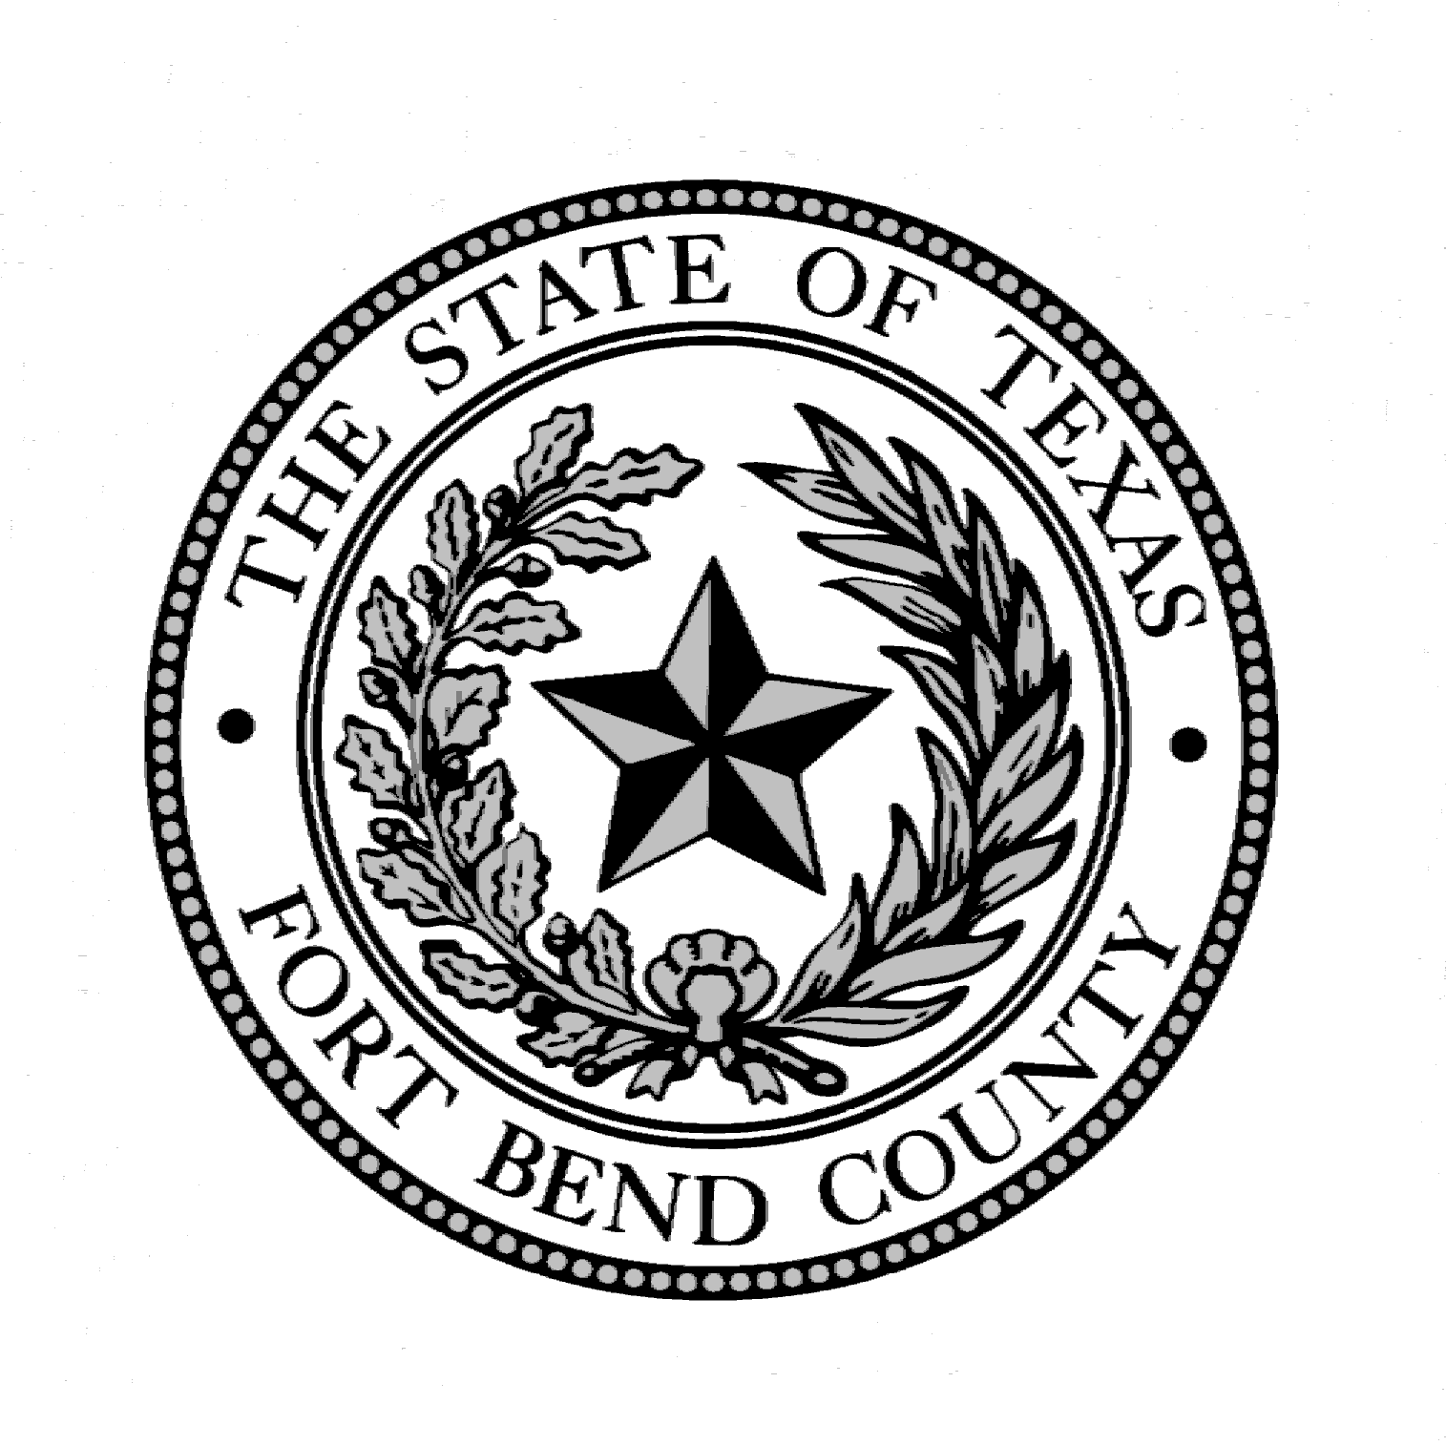

BAIL BONDSMEN REPRESENTATIVE

BALLOT

PLEASE CAST YOUR VOTE FOR THE BONDSMEN REPRESENTATIVE TO SERVE ON THE FORT BEND COUNTY BAIL BOND BOARD FOR THE 2024 CALENDAR YEAR. RETURN THIS BALLOT TO THE BAIL BOND BOARD ADMINISTRATOR'S OFFICE LOCATED IN THE FORT BEND COUNTY JUSTICE CENTER, AT 1422 EUGENE HEIMANN CIRCLE, SUITE 20242, RICHMOND, TEXAS, 77469
NO LATER THAN NOVEMBER 30, 2023
IN A PLAIN, UNMARKED ENVELOPE, WHICH WILL BE PLACED IN AN EXTERIOR ENVELOPE SIGNED BY THE PERSON SUBMITTING THE BALLOT.

_______________________________________________________
(Please print Bondsmen Name)

_____________________________________________________________
(Please print Bonding Company name)

Each individual licensed in the county as a bail bond surety or as an agent for a corporate surety is entitled to cast one vote for each license held to elect the Board member who is a surety or agent for a corporate surety.

