FORT BEND COUNTY BAIL BOND BOARD
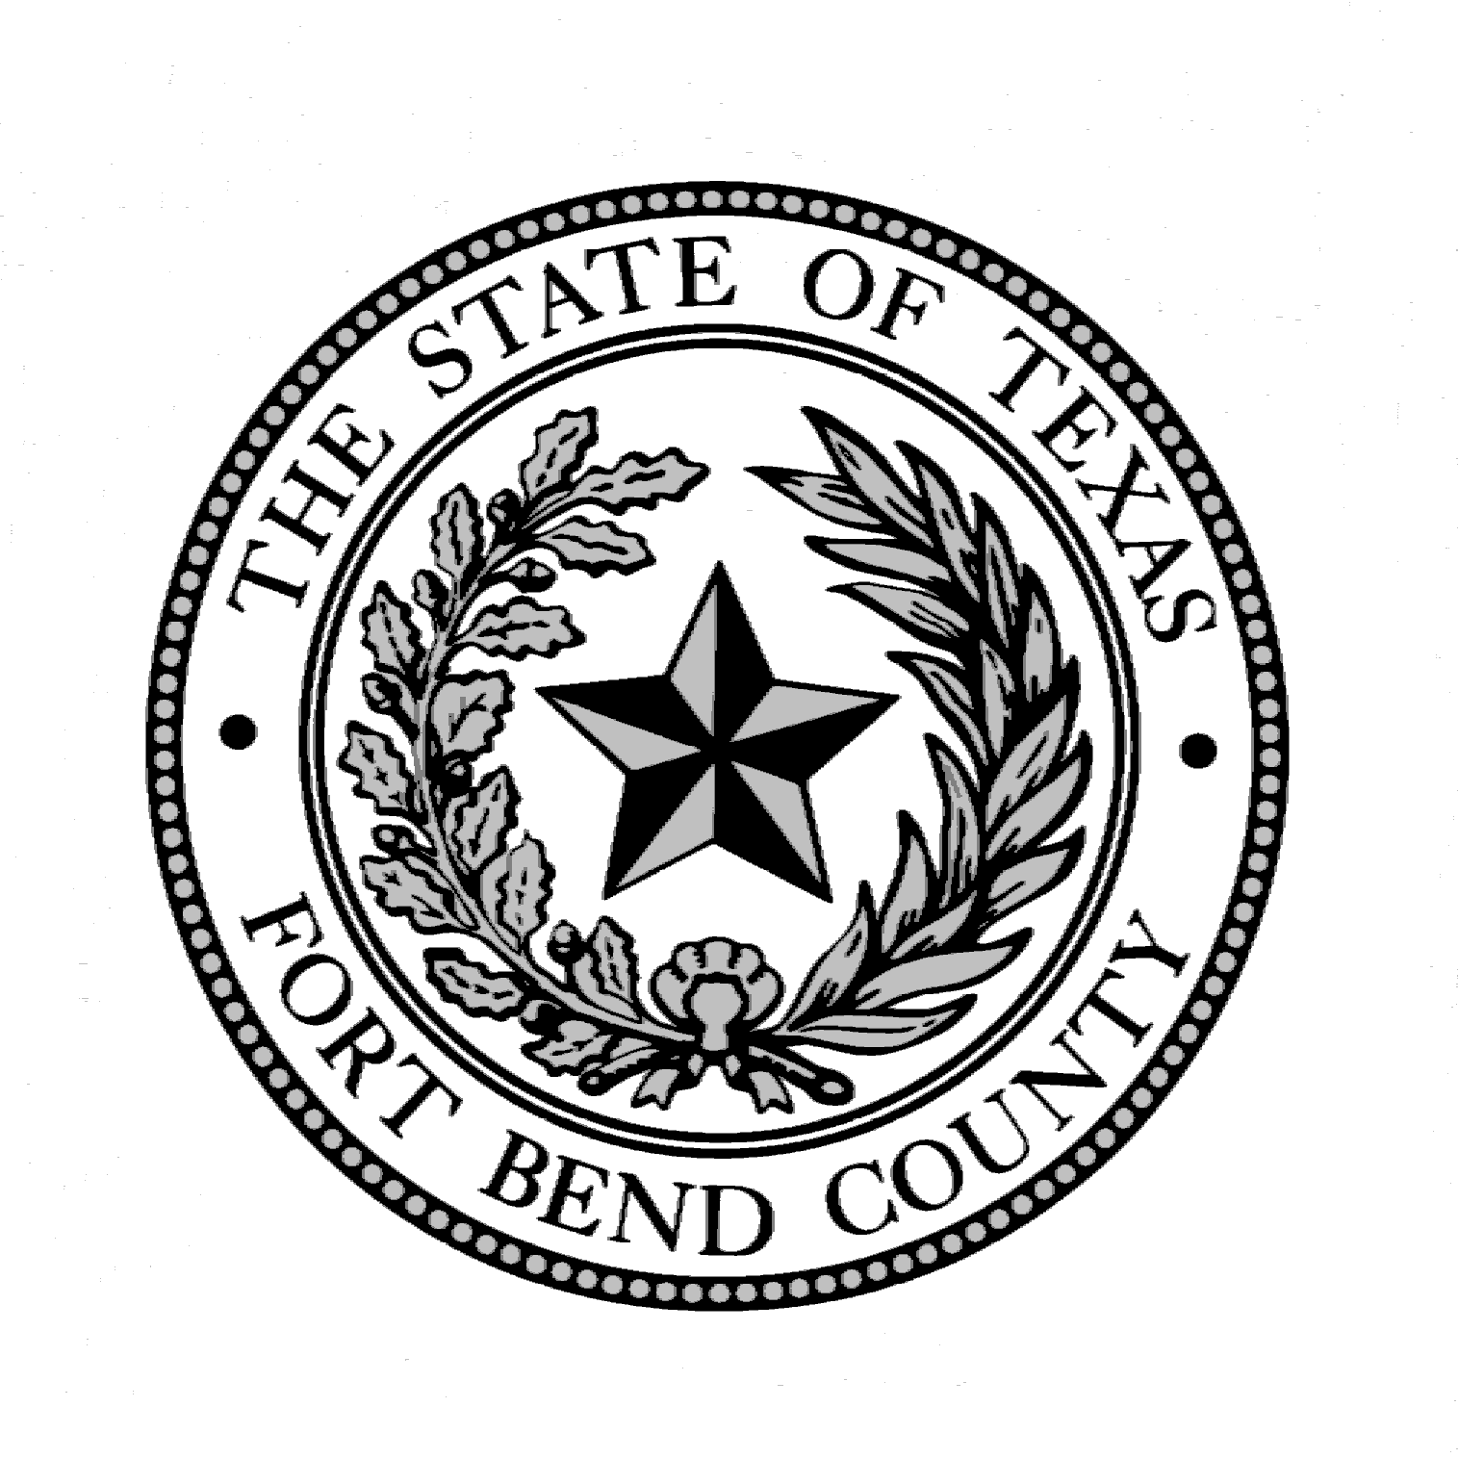

CRIMINAL DEFENSE ATTORNEY REPRESENTATIVE

BALLOT

PLEASE CAST YOUR VOTE FOR THE CRIMINAL DEFENSE ATTORNEY REPRESENTATIVE TO SERVE ON THE FORT BEND COUNTY BAIL BOND BOARD FOR THE 2024 CALENDAR YEAR. RETURN THIS BALLOT TO THE BAIL BOND BOARD ADMINISTRATOR'S OFFICE LOCATED IN THE FORT BEND COUNTY JUSTICE CENTER, AT 1422 EUGENE HEIMANN CIRCLE, SUITE 20242, RICHMOND, TEXAS, 77469
NO LATER THAN NOVEMBER 30, 2023
IN A PLAIN, UNMARKED ENVELOPE, WHICH WILL BE PLACED IN AN EXTERIOR ENVELOPE SIGNED BY THE PERSON SUBMITTING THE BALLOT.

_______________________________________________________
(Please print CRIMINAL DEFENSE ATTORNEY Name)

_

Each attorney who has a principal place of business located in the county and who is not legally prohibited from representing criminal defendants in the county is entitled to cast one vote to elect the board member who is a criminal defense attorney.

