FORT BEND COUNTY BAIL BOND BOARD
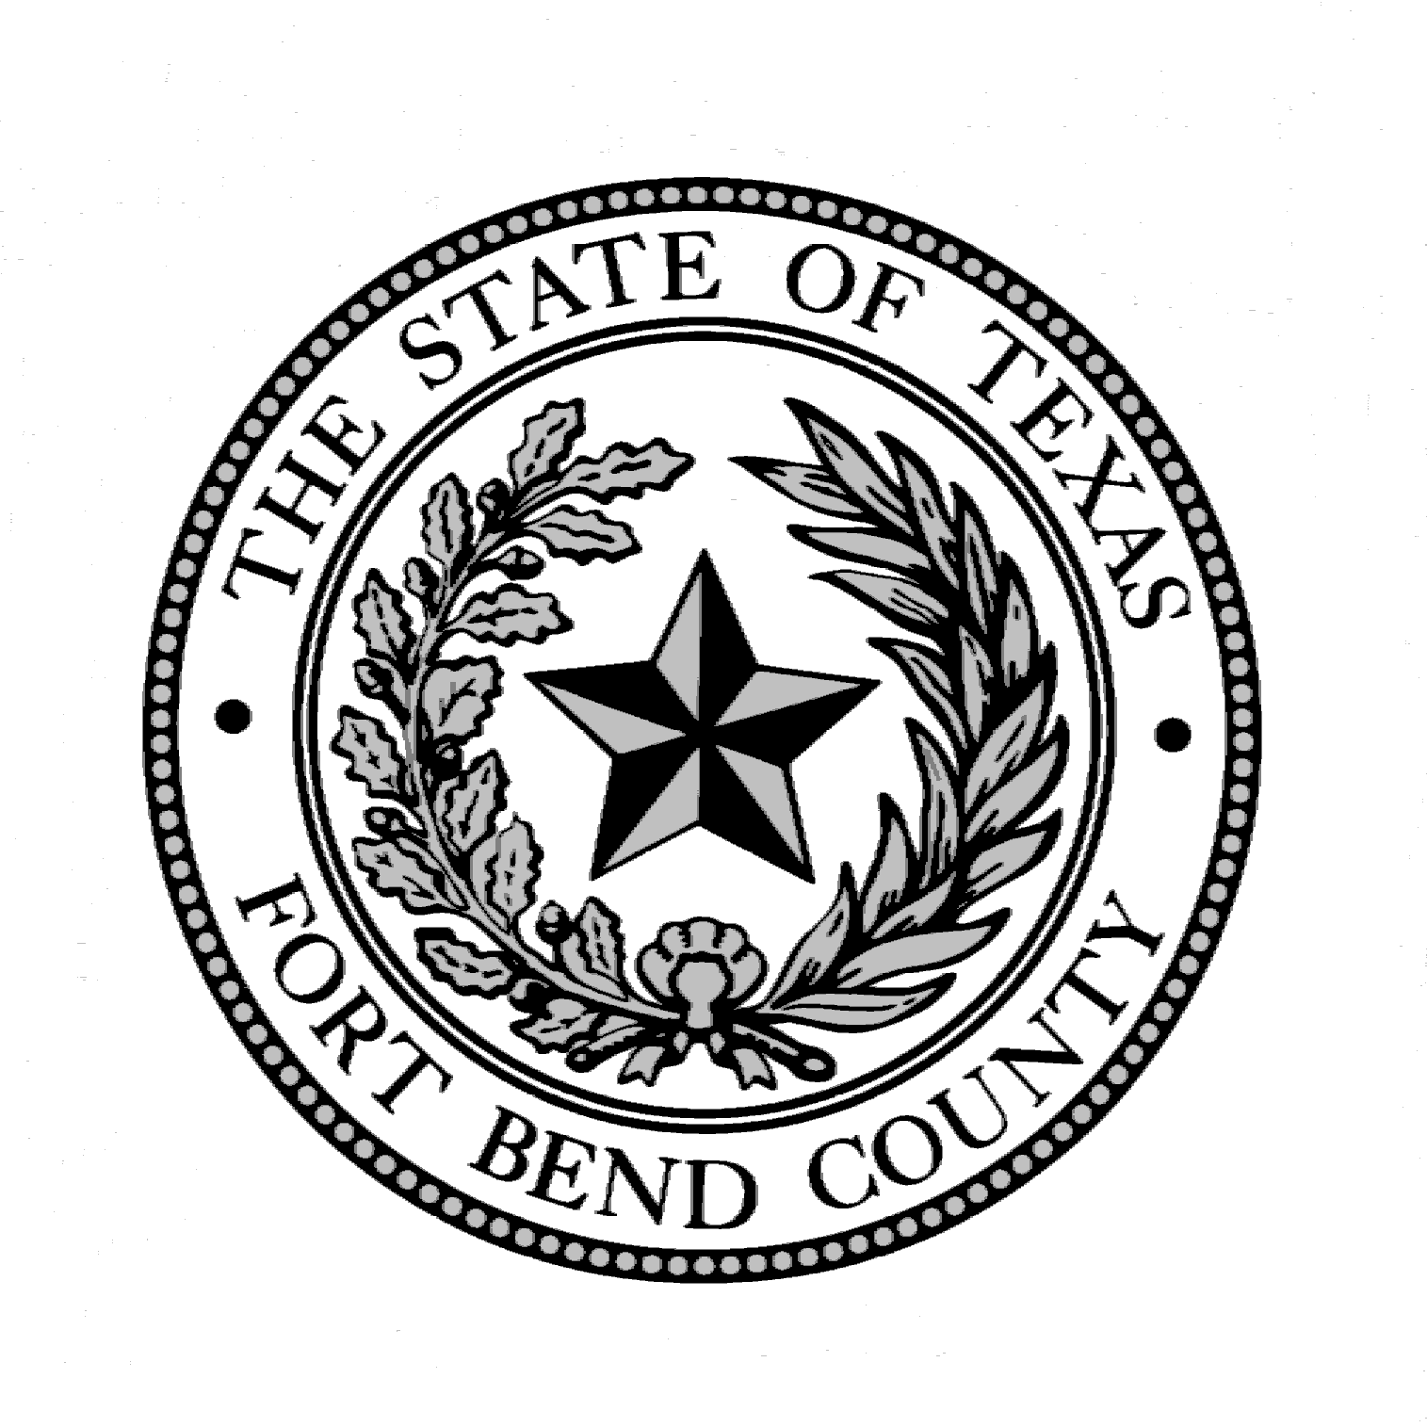

CRIMINAL DEFENSE ATTORNEY REPRESENTATIVE

2024 NOMINEES

DAVID KIATTA
NANCY LUSK
CLAUDIA P. AVALOS
GRACE NGOZI NWANGUMA

PLEASE SELECT YOUR CRIMINAL DEFENSE ATTORNEY REPRESENTITVE NOMINEE TO SERVE ON THE FORT BEND COUNTY BAIL BOND BOARD FOR THE 2024 CALENDAR YEAR. RETURN TO THE BAIL BOND BOARD ADMINISTRATOR'S OFFICE LOCATED IN THE FORT BEND COUNTY JUSTICE CENTER, AT 1422 EUGENE HEIMANN CIRCLE, SUITE 20242, RICHMOND, TEXAS, 77469,
IN PERSON NO LATER THAN NOVEMBER 30TH.

BALLOTS ARE AVAILABLE ON LINE AND IN THE BAIL BOND BOARD OFFICE.

Each attorney who has a principal place of business located in the county and who is not legally prohibited from representing criminal defendants in the county is entitled to cast one vote to elect the board member who is a criminal defense attorney.

